|  |  |
| --- | --- |
|  | Computer Network |
|  |  |
|  | Semester Project  Submitted to Sir Abdul Ghani |

**Hotel Management Network Design**

**Group members:**

Naveena Rashid 233697

Abeer Fatima 233666

Tayyaba Khalid 233700

**Contents**

**1. Introduction** 1

**2. Network Design** 1

**3. Configuration Details** 2

**4. Network Benefits** 3

**5. Conclusion** 3

**1. Introduction**

This report outlines the design of a reliable and efficient Hotel Management network to connect the Reception Desk, Security Office, IT Department, and Server Room. The network ensures robust communication, resource sharing, and centralized management. Subnetting is employed for segmentation and effective IP management.

**2. Network Design**

**1) Topology Overview**

The network consists of departmental subnets connected through routers. Each department is assigned a unique subnet with allocated devices, ensuring segmentation and efficient management.

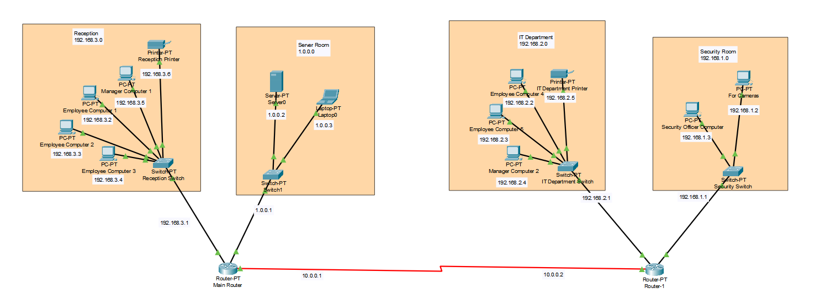

**2) Justification of Topology**

The design provides:

* Seamless communication across departments.
* Centralized management via the Server Room.
* Efficient resource sharing and scalability.

**3. Configuration Details**

**1) IP Addressing Plan**

Each department has been assigned a unique subnet:

|  |  |  |  |
| --- | --- | --- | --- |
| **Department** | **Subnet** | **Devices** | **IP Range** |
| Security Office | 192.168.1.0/24 | 2 PCs, 1 Switch | 192.168.1.1 - 192.168.1.254 |
| Server Room | 1.0.0.0/24 | 1 Server, 1 Laptop, 1 Switch | 1.0.0.1 - 1.0.0.254 |
| IT Department | 192.168.2.0/24 | 3 PCs, 1 Printer | 192.168.2.1 - 192.168.2.254 |
| Reception/Front Desk | 192.168.3.0/24 | 4 PCs, 1 Printer | 192.168.3.1 - 192.168.3.254 |
|  |  |  |  |

**2) Hardware Components**

|  |  |  |
| --- | --- | --- |
| **Component** | **Quantity** | **Purpose** |
| PCs | 9 | Employee workstations |
| Server | 1 | Centralized management of resources and data |
| Switches | 4 | Local network connectivity within departments |
| Printers | 2 | Document printing |
| Laptops | 1 | Server administration |
| Routers | 2 | Interconnect departmental subnets |

**3) Departmental Configurations**

* **Security Office:** High-speed communication with access to shared resources.
* **Server Room:** Central hub for file storage and network management.
* **IT Department:** Access to centralized resources and shared printing.
* **Reception/Front Desk:** Controlled internet access and inter-department communication.

**4) Routing Configuration**

Two routers are deployed for subnet interconnection, ensuring seamless communication and effective management.

**4. Network Benefits**

* **Efficient Resource Sharing:** Secure file and printer access across departments.
* **Scalability:** Easily accommodates additional devices or departments.
* **Reliability:** Topology ensures minimal downtime.
* **Centralized Management:** Server Room acts as the control hub.

**5. Conclusion**

The hotel management achieves robust communication and resource sharing while ensuring scalability and reliability for the guests to ensure their secure and reliable stay. This structured approach supports smooth operations and centralized control for a 5 Star hotel.